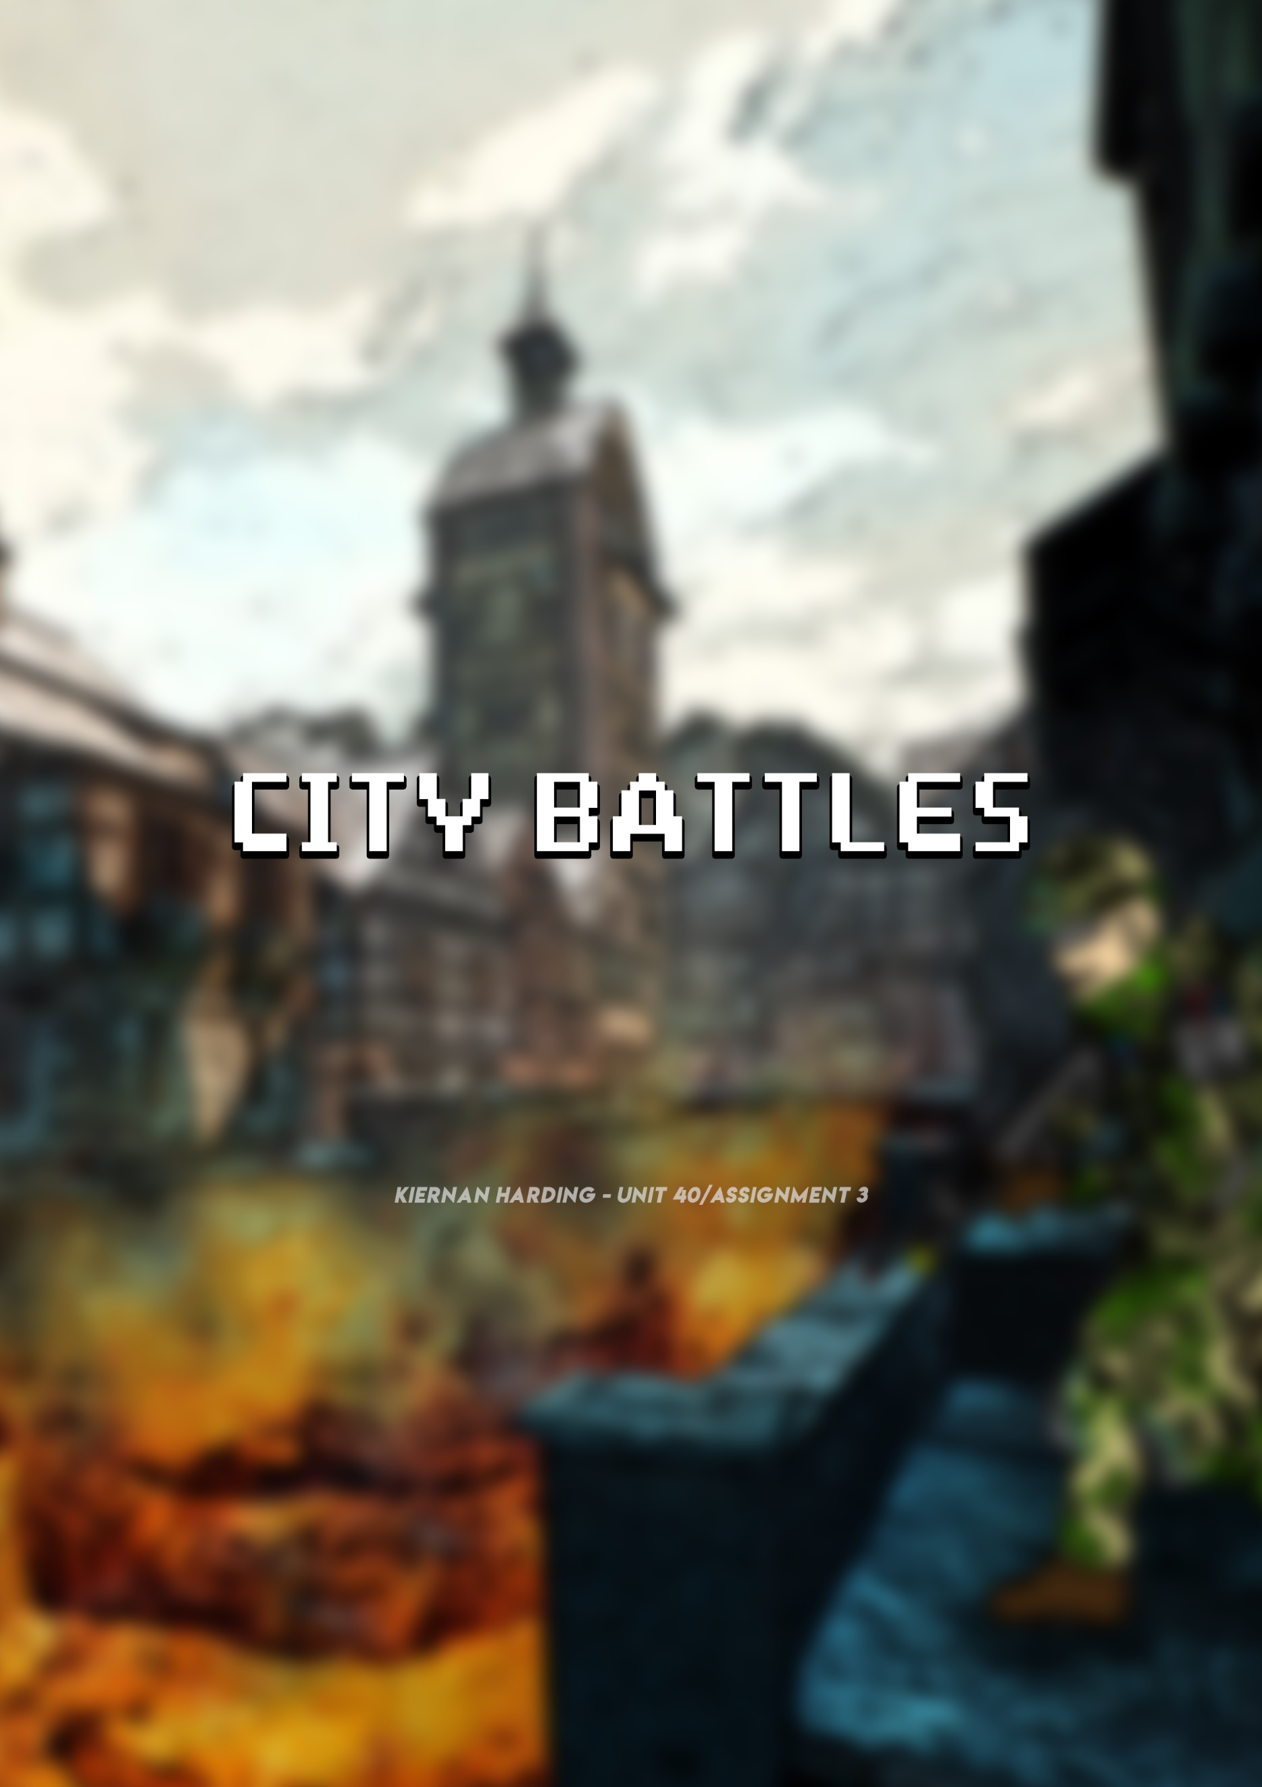

***Contents***

Story/Narrative 2

Unique selling point 2

Common questions 2

Characters 4

NPCs 6

Weapons 6

Music Overview 7

Game play 7

Game world: The territories 9

Landscape (Some shown in Storyboard) 10

Storyboard – How to win 10

Target audience 10

Mood board 12

Flowchart 14

# ***Story/Narrative***

In 2020, war has broken out within a modern city environment and left the city abandoned after two undercover groups went against each other to take it over. Now that the city is abandoned, many group leaders are looking to take it over. Therefore, they are being dropped from many different military aircrafts like helicopters and will have to fight it against another 99 players, to become the victor. All players will start with is a standard pistol with 2 magazines, so they have some form of protection. To have an advantage over other players, you will need to find military cases around the map. These will have things such as guns, attachments, armor and medication pills (for healing). What spawns into these crates will be completely random, as if not players would remember where the best equipment spawned. Players would need to play tactically to take out the opposition, by taking advantage of things such as tall buildings. However, players would still need to be on the move, so they are always in the safe zone, which can change every few minutes. Every player will get a certain amount of XP every game which can go towards things such as customization, even if they come last. However, if you win the game you will get an extra amount of XP and will rank up quicker. To rank up players will need a certain amount of XP, which will increase as you get to a higher rank. Ranks allows for novice players to play against each other, and skilled players to play against skilled players, giving less skilled players a chance of winning.

# ***Unique selling point***

# At this moment in time there are no Battle Royale games that take advantage of the First-Person Shooter genre and its immersive feel. Therefore, I believe that the gaming market will enjoy playing an FPS Battle Royale game, which will make them feel immersed in their surroundings. Compared to a 3rd Person Battle Royale players which won’t provide the same experience. Including both game types, will allow me to take advantage of both target markets. The other unique selling point is the competitive mode, which allows players to compete against each other to get the best ranks. If a game has ranks, showing who is better, it makes a game very addictive as people don’t want to stop until they’re better than their friends or favourite YouTubers or Streamers. Furthermore, there is a lot of individual pieces of customization that people can earn within the game. As I believe that the best customization should be earnt not bought.

# ***Common questions***

***What is the game?***

The game that I want to design will implement the concept of Battle Royale, along with First Person Shooter (FPS) games. Players would be dropped into a central city area which looks like a modern war zone. It will be a ‘free-for-all’, meaning all players are against each other. There will be a maximum player limit of 100 people on the map at once, and the last player alive will win. Although it’ll be based around modern war, I would like the game to be cartoon themed, like games such as clash of clans. To spawn into the map, players would be randomly dropped by military aircrafts, in to different areas. To make the game a bit fairer, compared to other Battle Royale games, players will spawn with a basic pistol, so they have some way of defending their selves. In addition to this, each player can choose from a set of 5 different characters, who have a set of different perks and abilities. You would have to select the perks that most suit your game style. Each character’s perks and abilities would do something different, allowing you to play in a different way. For example, one character may be much quicker, however, another character may be slower but have some type of extra armor. Therefore, if you like to sprint around the map you’d pick the ‘Rapid’ character set.

After spawning in, players will need find weapons and attachments, which will be placed in random military cases around the open world. Players will need to move to a safe zone every few minutes, as if not they will be at risk of being shot or bombed by military aircrafts. Players will not have a health bar like other battle Royale games, but their HUD will get filled with more blood, as their health decreases. The only way to regain health is over time, which will be very slow, or through taking ‘Pills’. As your health regenerates, the blood in your HUD will decrease. This will be implemented to move players nearer to each other, so they cannot just camp. So, there’s something to aim for in the game, I would want to implement a ranking system. This is so novice players would play against each other, whereas skilled players would also play against skilled players. This would make sure that when you win it feels more rewarding, as its much more difficult. In addition, it is good competition between friends, to see who can be the best!

***What genre is your game?***

Like stated before, my game will implement components of both Battle Royale and First-Person Shooter games. This is because they are some of the most loved and played game types. As it is using the angle of First-Person, you will feel more immersed within the game. This is important, as you want the player to feel like they are there in real life. In addition to this, I would love the game to be programmed so it can be used using Virtual Reality kits. The whole game is based around trying to be the last player alive, just like in the book/film ‘The Hunger Games’. It also exploits the idea of finding items, which you can use in different ways to win the game.

***Why create this game?***

I understood that a lot of the gaming community is obsessed with two game genres. These game genres are First-Person Shooters and Battle Royale. Therefore, I thought that I should implement the best parts of already existing games in these genres. I wanted to know what it would be like to feel immersed in a Battle Royale game that has a distinct ranking system, which makes players competitive. Especially as this would keep me enticed over already existing games. I used the First-Person Shooter genre to base my game around, as I like to be immersed in a gaming environment and feel like I’m in control.

***Where does the game take place?***

The game mainly takes place in a reasonably modern city which has been abandoned after a recent civil war between two undercover government groups in 2020. Players will be able to enter buildings and utilize the height advantage of tall city skyscrapers and other miscellaneous buildings. Although it will mostly be based within a central city environment, there will be two slightly different environments on the outskirts of the city. These will be the suburbs, where there will be tight built up spaces, with standard family homes. Some of these homes will be broken due to the war, which broke out. The last environment is a forest, with some open grass land. Here, players can hide within the trees to sneak up behind other unsuspecting players.

***What do I control/how many characters do I control?***

In City Battles you control a single character, which you can customize until your hearts content. This character will have been part of a secret military group who has been ordered to take over the city, no matter the cost of life. You will control all the characters actions such as shooting the weapon, sprinting, sliding and so on (I will talk about all the actions further on in the assignment). However, as you need to be the last alive, the main action is utilizing your weapon and handling a knife in close quarters. As there will also be a ‘Duos’ mode, so you can play with your friends, if you die you will be able to control what you see of their screen. This is so you aren’t too bored when waiting to play another game with them. You can also aid your teammate in winning the game, as you will still get winning XP.

***What’s the main focus/goal?***

The main focus of the game is to be the last player alive out of the 100 gamers playing. However, if you can’t manage to win, you will want to stay alive as long as possible, as you will receive more XP. As soon as you are dropped off by the military aircrafts, you will need to find the military cases. These will contain your key to success, as they will have weapons, armor, medication pills and attachments within them. Furthermore, you will want to get as many kills as possible when trying to survive, as you will receive an amount of XP for every kill you receive. Thus, giving you an incentive to get kills, as XP goes towards things such as customization and your rank.

***What’s different?***

There are three main differences of my Battle Royale game, City Battles, over already existing games. Firstly, it is in First-Person, meaning that you feel more absorbed into your surroundings than a 3rd Person game. This is because you get to play as yourself, and not feel like your controlling an external character. Secondly, there is a well-developed competitive ranking system. This ranking system works through 5 main ranks, with 10 individual levels between them. As you earn XP, you will eventually climb up through the ranking system, until you earn Emerald 1, the best possible rank. Finally, there’s lots of different customization players can earn through getting more XP, and getting a better rank. Especially as you will get special clothing and other features for being in a higher rank.

***What platform it’s on***

The target platform for the game I am designing would be PC. This is because the game controls would be complex and require many keys, and possible macros. This is also because computers can have more advanced components, which can run the game better. As there is a large open world involved, users would need an advanced PC, with newer/quicker components. However, there would be different video settings, so players with lower end PCs could still play on lower settings. Despite this, I would like to see if it could be altered slightly for use on consoles such as the Xbox One and PS4. This would be good, as it would reach the more casual gamer.

# ***Characters***

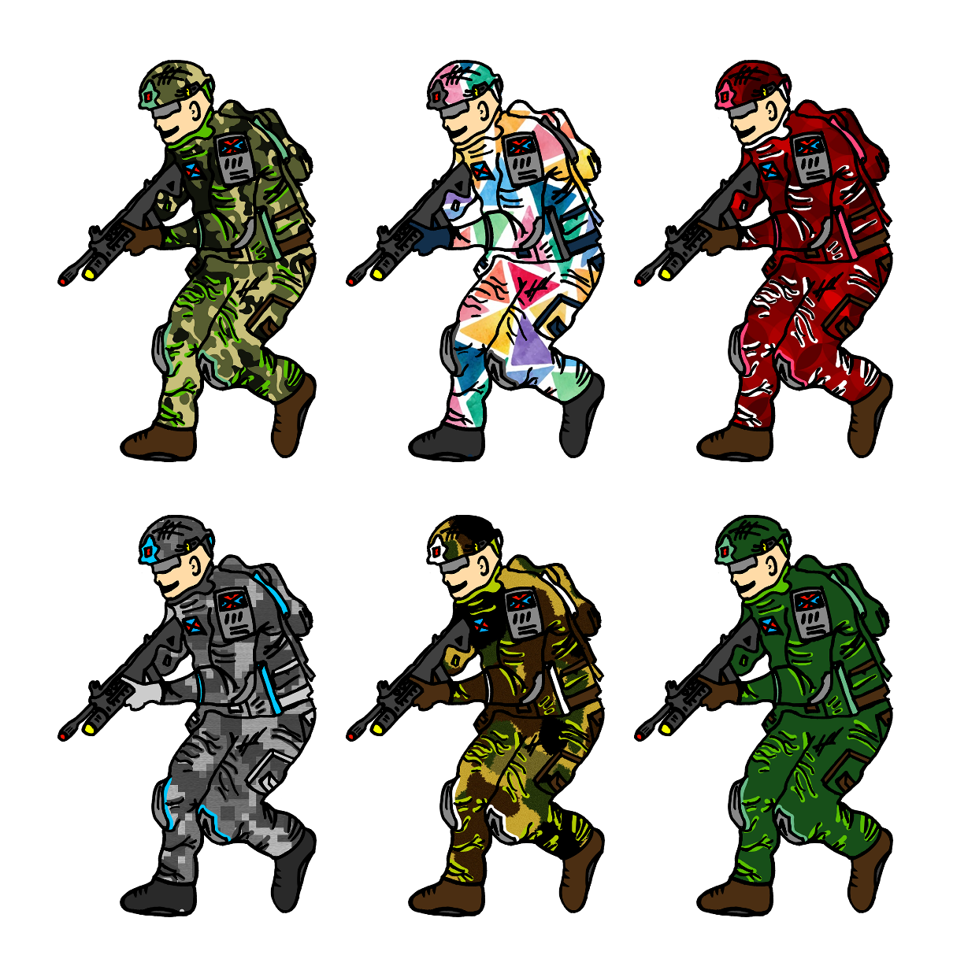There is only one main character you can be within the game I am designing and that is yourself. You need to imagine that you’re in a ‘Hunger Games’ like environment, where you will need to fight your way out to survive and win the game. As this is a multiplayer game I have allowed players to have lots of customization. The things you can customize can be your helmet, top, bottoms, backpack, knee/shoulder pads, glasses, shoes and weapon camos. You can receive customization through playing the game and randomly earning pieces, or buy them from the store, through an in-game currency. Some of the customization, isn’t exactly camouflage, however, I realize some players love to stand out from the crowd and have the best gear! There are some examples of customization on the left of what you could look like with a full matching clothing set.

# 

# ***A close up of a box Description generated with high confidence***

# ***NPCs***

I have not got any non-playing characters within my game, City Battles. This is because my game is solely based around online multiplayer. Therefore, there are 100 individual gamers from around the world, controlling a single character, with the drive to win the game. As there is so many individually controlled players, NPC would be pointless in the game and would be an oddity.

# ***Weapons***

There are 4 main types of weapons within my game. The first one is a standard issue Pistol, called the ***Glock 38***. All players will spawn with the Glock 38, which is just for general protection at the start of a game. It will have quite low damage, a high firing rate, lots of recoil and only 2 magazines of 12 bullets.

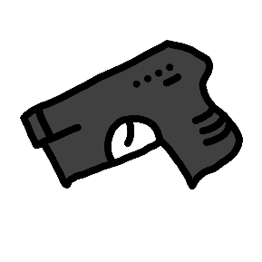

The next weapon is an Assault Rifle, called the ***Beryl***, which can be switched from fully automatic to a burst fire mode and is most effective at a medium range. Its damage is quite high especially if you’re hitting the head and has a magazine size of 32. Finally, it has reasonably low recoil due to the practical fire rate.

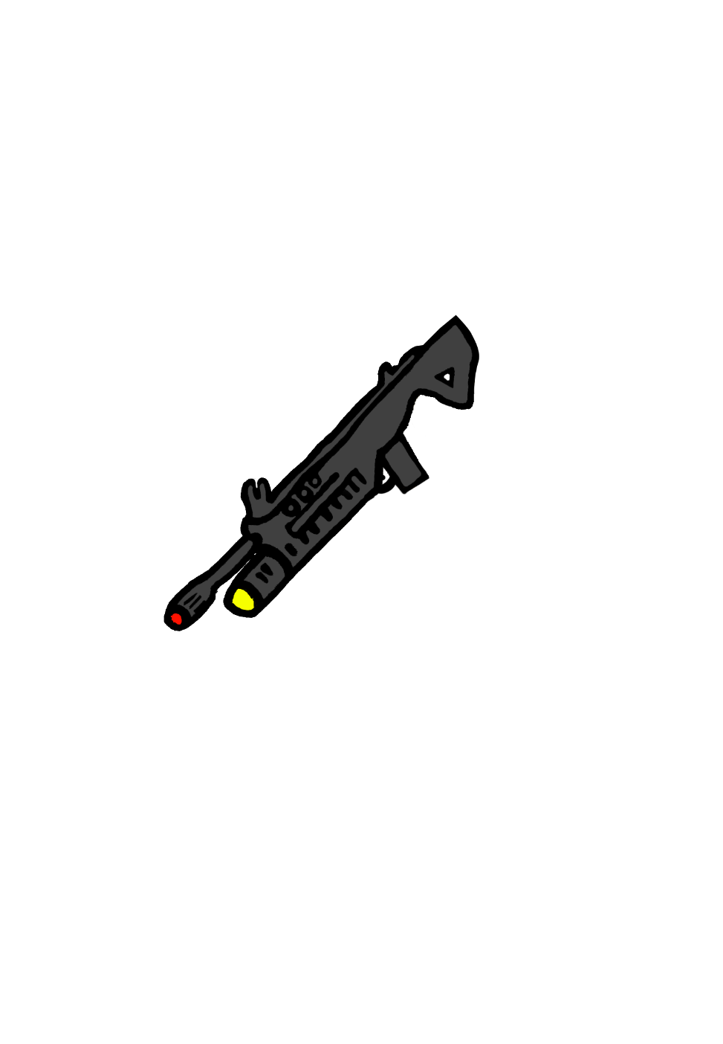

The next weapon, which is a community favorite, is a Sniper Rifle, called the ***OSV 9***. As this is a bolt action Sniper Rifle, it has a very low fire rate, but is very effective at medium to long range. Making it the perfect weapon to utilize in roof top skyscrapers. As a lot of players find it annoying when a Sniper Rifle isn’t a ‘one shot kill’, the Sniper Rifle in City Battles will be.

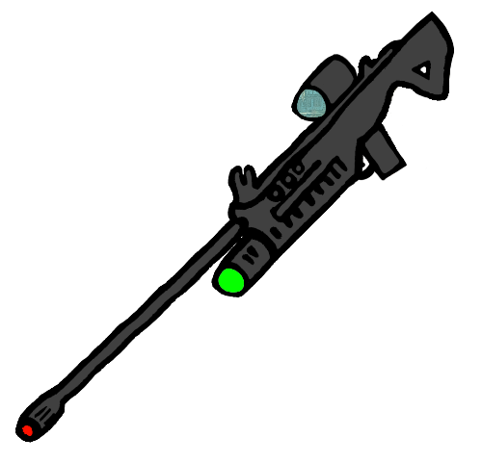

The final weapon, which isn’t a gun, is a Knife named the ***Kataquo.*** This is another weapon players will spawn with, and is only useful when you are right next to a player. However, it will kill instantly, when hit into a player.

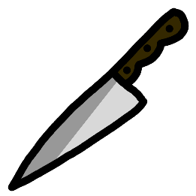

***Camos***

As I have already stated there is a lot of customization within City Battles. One of the types of customization is gun camouflages, which can be earnt through playing the game. The following are some examples of what you could receive.

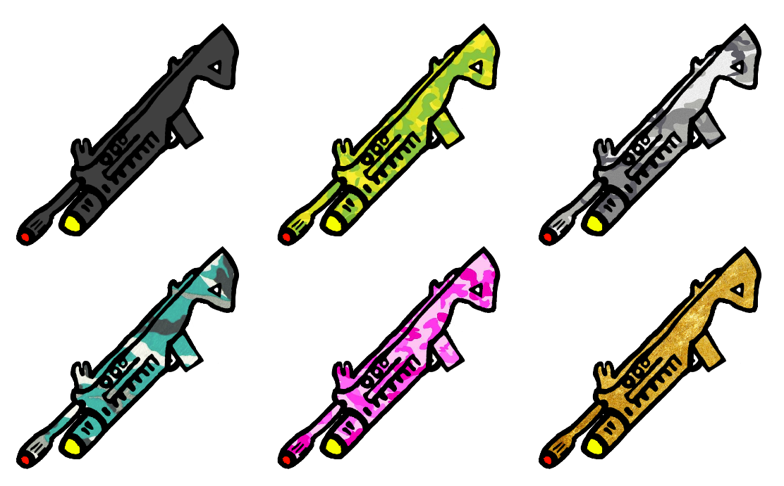

# ***Music Overview***

Music will only be played at two points within City Battles. This will be in the main menu when you are waiting to get into a game and at the start of a game to show the intensity. The music that will be played will be an intense beat, that would get peoples adrenaline pumping.

# ***Game play***

***Experience***

You will feel immersed within my game, City Battles, as a First-Person experience will make you feel like you’re actually in the game. It will be action packed, which can be fast or slow moving depending on how you decide to play. Players will enjoy the realistic, yet cartoon like theme which will give them a completely different experience to any other game already on the market.

***Game rules***

There are no major game rules as it is a multiplayer game. However, as you will be aiming to win you will need to play tactically to take out the other players. The only thing that could be seen as a rule, is that you will need to stay in the safe zone, as if not you will be killed by bomber planes. However, this is for your own good!

***Feedback interface***

There are a few things that will show up on the feedback interface, which will be beneficial to the person playing. The first one is the health bar, which will change from a standard white colour to red when you go under 50% health. This health bar will be positioned in the bottom left side of the screen. Also, when getting shot and your health has decreased, red will show up around your screen in the form of blood to emphasize that you are dying and that you need to take medication pills. Positioned in the bottom right of the screen will be your ammo. Their will be a large number showing the amount of ammo left in the current magazine. Followed by a slightly smaller, transparent number, which shows all the ammo you are carrying. You will have an inventory which can be accessed from pressing the key ‘E’ as it’s not constantly shown on the screen. This will show all of the items that you have collected from dead players/military cases and the health of your armor/helmet. The final parts that will be present in your interface are the number of players left alive, who has been killed by who, and how long until the safe zone gets smaller, along with a map that can be toggled through the ‘M’ key.

***Player actions***

There are many player actions that can be performed through certain keys on the keyboard.

***Standard Run (Forward) –*** W

***Left –*** A

***Right -*** D

***Back -*** S

***Sprint –*** W and SHIFT

***Jump –*** Space Bar

***Crouch (Kneeling) -*** CTRL

***Prone (Laying on stomach) –*** CTRL x 2

***Switch Weapons –*** Number Keys or Scroll Wheel

***Shoot or Melee –*** Left Click

***Aim Down Sights (ADS) –*** Right Click

***Use Key (Pick up item, open door, etc.) –*** F

***Inventory –*** E

***Take Pills -*** Q

***View Players -*** TAB

***In Game Menu –*** ESC

***Map –*** M

***Win condition***

To win the game you will need to be the last player alive, as once you’re dead, you’re dead. Only one can survive. To do this you will need to find weapons to take out the opposing players, before they kill you. If you do not win, try again, practice makes permanent.

***Challenges***

The main challenge players will have to face is each other! This is because they will have to fight their way to be the victor, which will reward them with customization and XP.

***Abilities (Character Set)***

Each player can choose from a set of 5 different characters, who have a set of different perks and abilities. You would have to select the perks that most suit your game style. Each character’s perks and abilities would do something different, allowing you to play in a different way. For example, one character may be much quicker, however, another character may be slower but have some type of armor. Therefore, if you like to sprint around the map you’d pick the ‘Rapid’ character set. These character sets would be balanced so one of them wasn’t a lot better than another.

# ***Game world: The territories***

***Overview***

The game is based in a modern city with suburban and forest areas surrounding it. The city has been abandoned after two undercover groups went against each other to take it over. Some of the buildings have now either fallen down, been set on fire or fully are still fully functional. In the suburbs, where there will be tight built up areas, with standard family homes. Some of these homes will be broken due to the war, which broke out. The last environment is a forest, with some open grass land. Here, players can hide within the trees to sneak up behind other unsuspecting players. Although there are areas surrounding the city, there will be some great sky scrapers in the city center, where the best loot can be found or utilized by snipers.

***Key locations***

The key main locations as mentioned before are the main city center, the suburbs that surround the city center and the forest. These types of locations will be scattered around the map along with a few small towns.

***Travel***

You will be able to travel around the map in a few ways. The first and most simple way is by foot. Although this is slow, it can be most effective as you can find military cases and kill enemies as you go. Secondly, you can find an abandoned car to hotwire, and drive to a specific location. This will be your most efficient option. Lastly, you can take a 50cc bike. This is quicker than walking, however, you can get shot off of it and you don’t have access to your weapon as you’re controlling the bike.

***Weather***

The weather across the map will depend on the game you play. For example, it can just be sunny, foggy, which will limit your viewing distance, raining, snowing or even be based at night! This means that you can have a different immersive experience every time. You may even need to change your playing style depending on the weather.

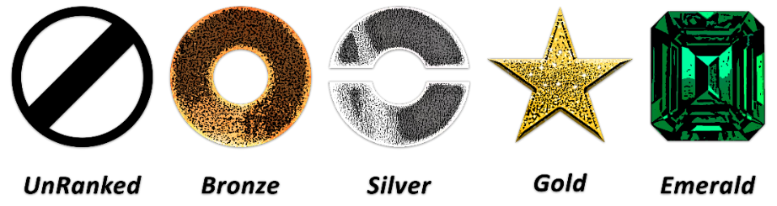***Level design***

The ranking system that I am implementing will have 5 main ranks, followed by 10 individual levels within each rank. Being ‘UnRanked’, means that you are such a poor player which is not worthy or an actual rank. However, if you are in Emerald, you are the best of the best.

# ***Target audience and why it suits them***

As this is a war based game, with blood and gory, it will have to be at least a 16 plus. However, I believe that some children as young as 12 would be looking to play it. As this is a fast paced, strategy game, players would need to have a good reaction time, along with a very good idea on how to trick other players out. As there is a ranking system involved within every element of the game, it may not entice the casual, everyday player. However, as most people are very competitive and will want to beat their friends, it will entice people between the ages of 16-30. I would say that this game would be aimed at males, however the female gaming community has grown, so both genders would be enticed. The game suits my target audience as they enjoy being immersed within a virtual environment, which makes them feel more powerful than they actually are. Following this, avid gamers love to play a competitive mode, so they can show off how good they are at the game, compared to their peers.

# ***Landscape (Extra landscapes shown in storyboard)***

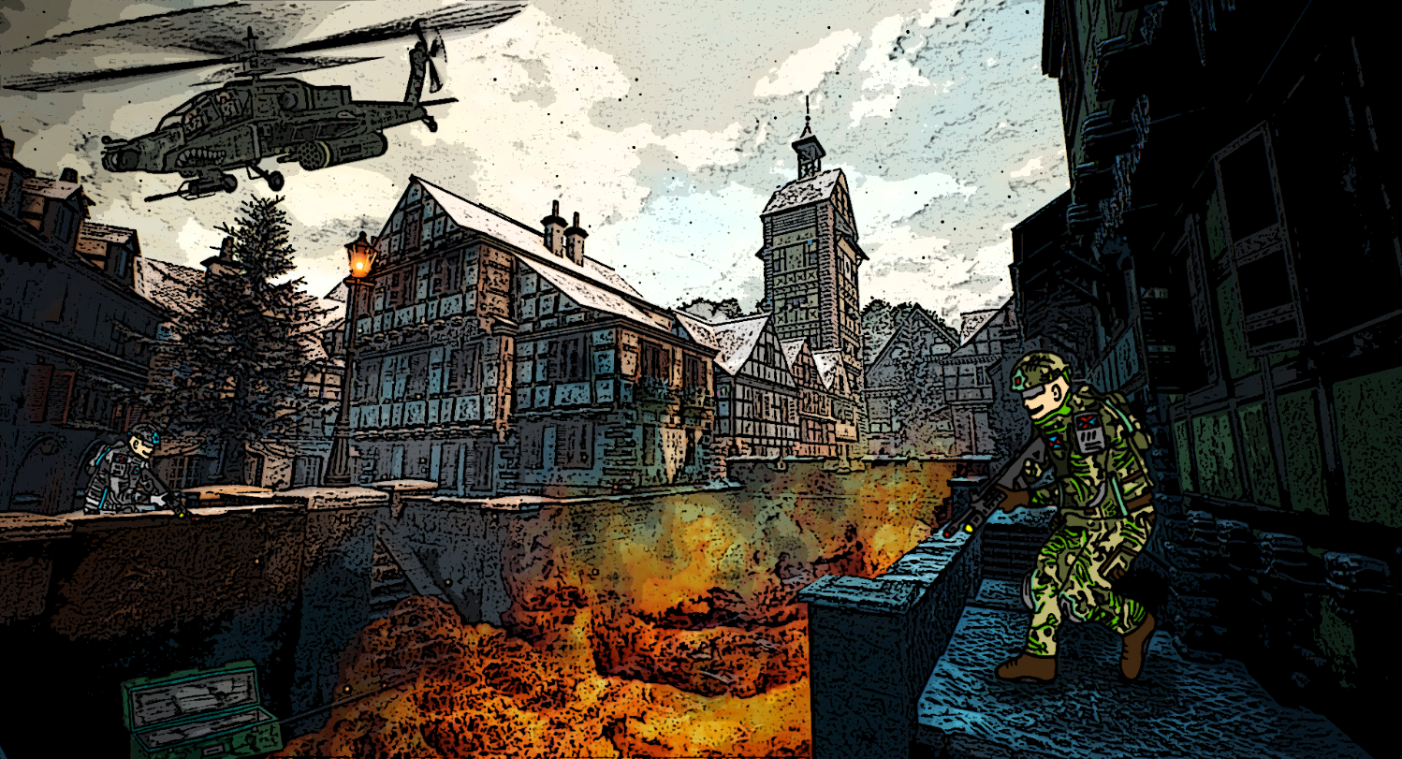

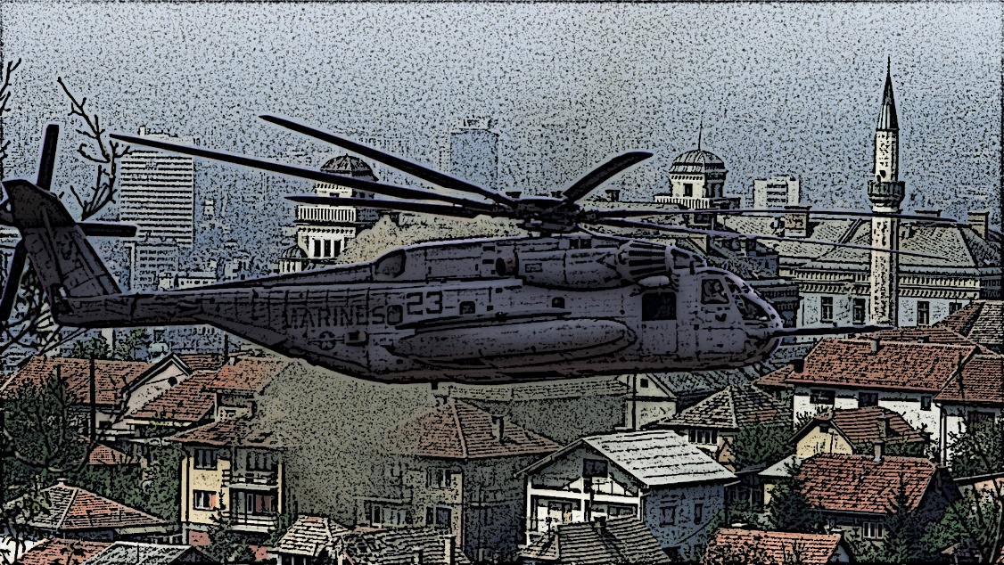***Storyboard – How to win…***

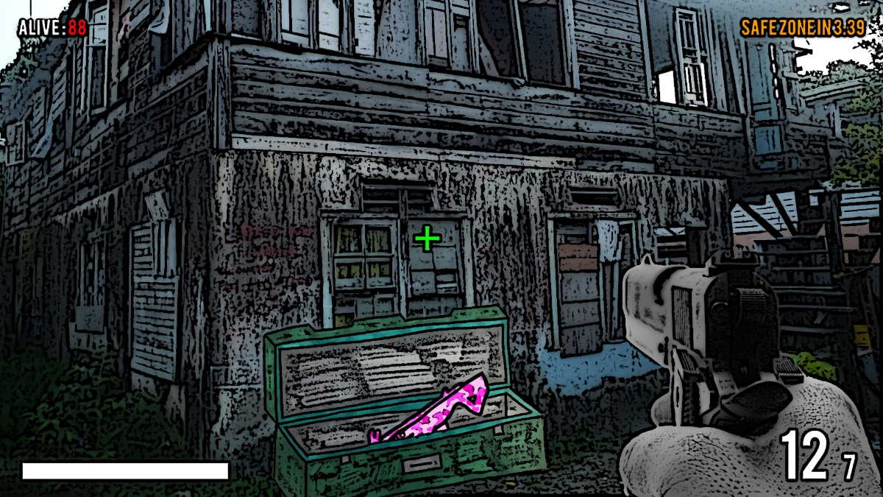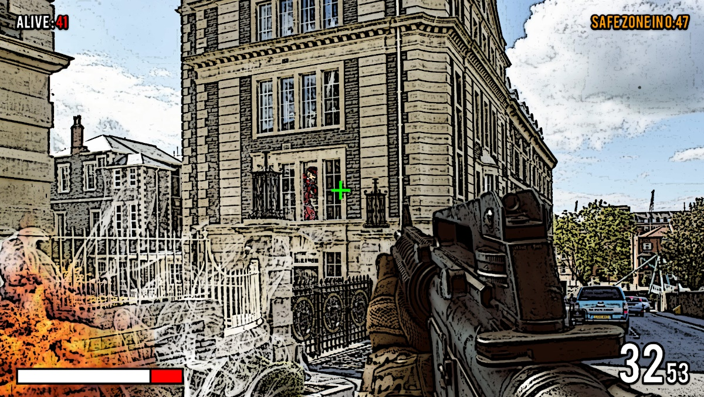

# 

# 

# 

# ***Mood board***

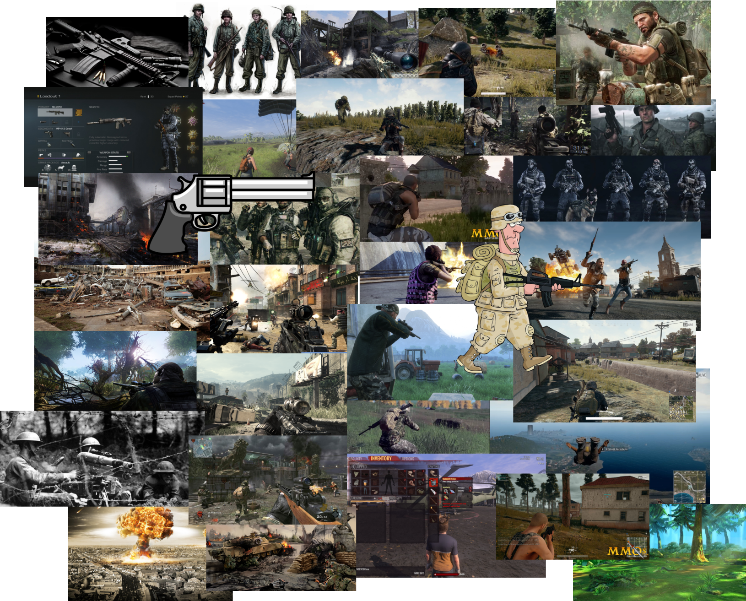

# ***Flowchart***

